Lesson 7 Sequences

Oral and mental starter 10 minutes
Ask pupils to continue sequences such as:
Objectives
Generate and describe sequences (Y7, 8)
Vocabulary
sequence, term, position,
term-to-term rule,
position-to-term rule
0.7, 0.4, 0.1, … 1005, 1003, 1001, …
1, –2, 4, –8, … 1, 0.5, 0.25, 0.125, …
Make sure the level of difficulty matches examples in the Framework (pages 144–145).
Q What is the rule to get the next term?
Explain that you have been using a term-to-term rule to describe these sequences.
Extend the activity: give pupils the first three terms and ask for the 4th, 5th, 10th terms.
Make sure that pupils realise that there are pitfalls in continuing sequences. For example, ask them to describe these sequences:
1, 2, 4, then 8, 16, … 1, 2, 4, then 7, 11, …
Now give pupils the first three terms of a sequence. Ask them to suggest what the 4th and subsequent terms might be. Point out that the same few given terms can lead to several different sequences.
Spend a few minutes considering how the sequence 1, 4, 9, 16, … can be described using term-to-term and position-to-term rules.

Main teaching 40 minutes
Show the first set of shapes on OHT M7.1 and ask a pupil to draw the next shape in the pattern.
Objectives
Generate terms of a sequence using term-to-term and position- to-term definitions of the sequence (Y8, 9)
Vocabulary
sequence, term,
nth term, general term,
position-to-term rule,
expression, justify, symbol, pattern, generate
Resources
OHT of M7.1
OHT of M7.2 (for plenary)
By the end of the lesson
pupils should be able to:
• understand sequences
• calculate terms in a sequence
• express a general term in words and symbols
• explain how the elements of a general term relate to the original sequence
Framework supplement of examples, pages 155–157
Levels 5 and 6
Q How many rectangles will there be in pattern 7? How did you work it out?
Bring out through discussion that they have used the term-to-term rule (as in the starter).
Q How many rectangles are there in pattern 20?
Ask pupils to discuss this in pairs and record their values.
Organise the values in a table.
Pattern | 1 | 2 | 3 | … | 7 | … | 20
No. of rectangles | 5 | 8
Ask pupils to explain how they got the 20th term.
Counteract the misconception that you multiply the 2nd term by 10 to obtain the 20th term by offering a counter-example from the table, e.g. the 1st and 3rd terms.
Ask pairs of pupils to work out how many rectangles there are in pattern 50, and to explain their method.
Model how to write the correct general term in words and symbols, linking the explanation to the diagrams. Make sure that links are made between the numerical and spatial patterns. For example (referring to the lower diagram on OHT M7.1):
Think of the original two rectangles (on the left-hand end). Each time three rectangles are added to form the next pattern. So:
Number of rectangles = 2 + pattern number × 3 (this is a position-to-term rule)
Further examples are available in the Framework supplement of examples, pages 155–157, and on previous Key Stage 3 test papers.

Plenary 10 minutes
Show OHT M7.2, developed from a 1996 test question. Recap key language by asking pupils to make statements about this new sequence. For example:
The 3rd term is …
The term-to-term rule is …
The position-to-term rule is …

Tile patterns M7.1
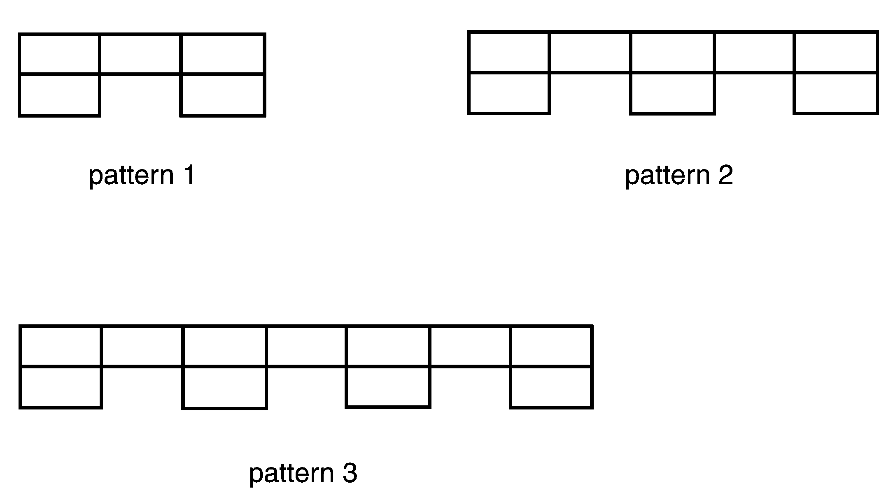

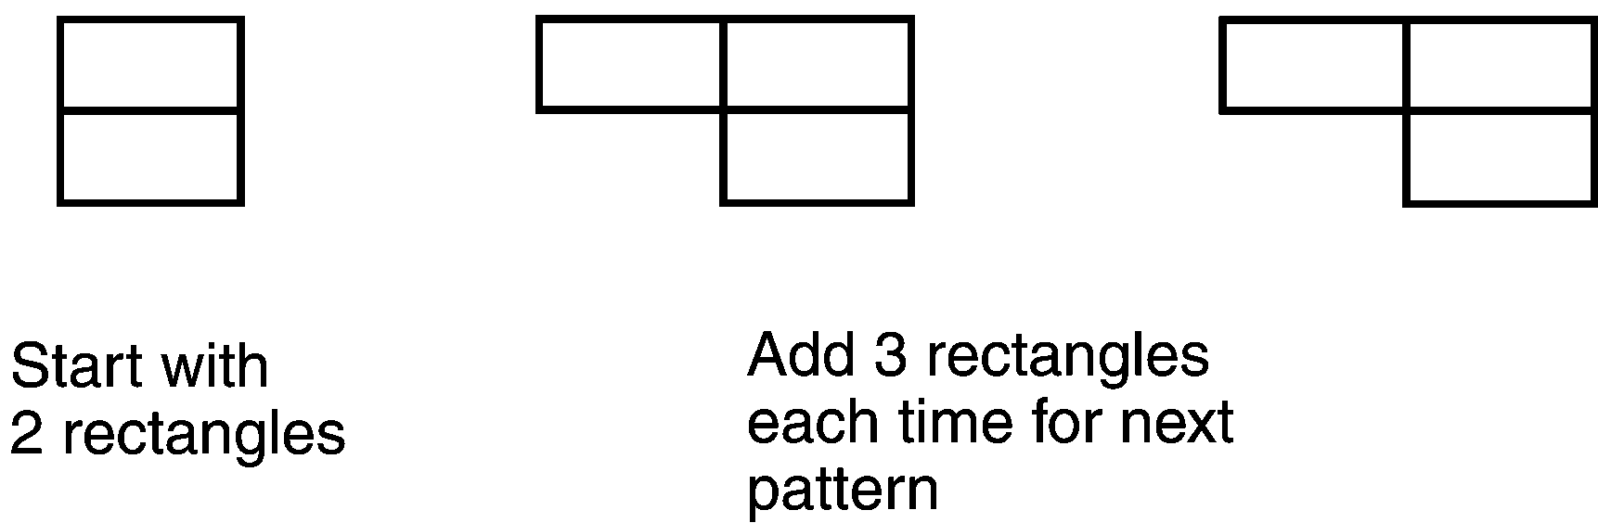

Windmills M7.2
This series of patterns is made with grey and white tiles.
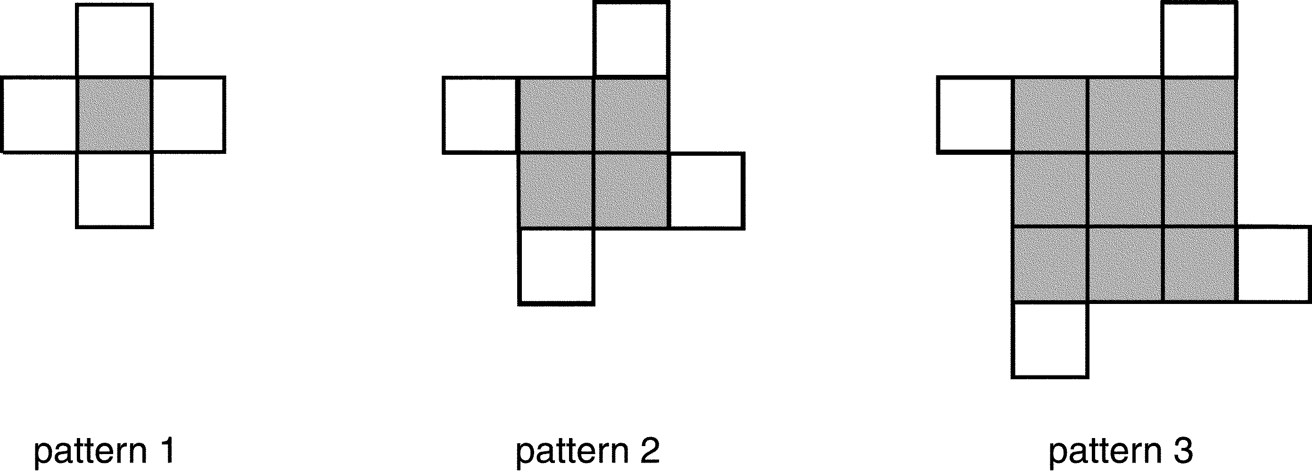
(a) How many grey tiles and white tiles will there be in pattern 8?
(b) How many grey tiles and white tiles will there be in pattern 16?
(c) How many white tiles will there be in pattern n?
(d) How many grey tiles will there be in pattern n?
(e) How many tiles altogether will there be in pattern n?

